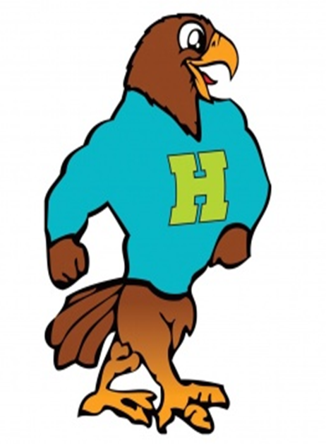

**Herbert Akins Road Elementary**

**Kindergarten Grade Supply List 2024 - 2025**

|  |  |  |
| --- | --- | --- |
| Item | Amount Needed | Notes |
| * 3-prong, 2 pocket heavy plastic folder | 1 | Solid color, please DO NOT write names on them |
| 3-hole zipper pencil pouch with transparent window and sturdy zipper | 2 |  |
| * ELMER’S glue sticks | 4 pack or larger |  |
| TRACKS 1, 2, 3 - 24 Count Crayola Crayons | 4 boxes | Note: Only Tracks 1, 2, & 3 |
| TRACK 4 - 10 pack of Crayola Twistables | 1 pack | Note: Only Track 4 |
| Ticonderoga Pencils | 1 box |  |
| Fiskars Blunt Tip Scissors | 1 pair |  |
| Headphones | 1 pair | No ear buds please |
| Roll of Paper Towels | 1 roll |  |
| Clorox Wipes | 1 container |  |
| Baby Wipes | 1 package |  |
| Backpack | 1 | No wheels, Standard size |
| Leakproof Water Bottle | 1 |  |
| Standard Sized Towel | 1 | Labeled with name on tag/For rest time |
| Full Change of Clothes | 1 | In a ziplock bag, labeled with name |
| BOYS ONLY:  8.5 x 11 110lb White Cardstock | 1 package |  |
| BOYS ONLY: Box of Tissues | 1 box |  |
| GIRLS ONLY:  8.5 x 11 110lb Colored Cardstock | 1 package |  |
| GIRLS ONLY:  Expo Dry Erase Markers | 4 pack or larger |  |

**\*\*Individual teachers may request additional supplies to support learning in their classroom. Please check in with your teacher at our Meet the Teacher event in July. Feel free to bring supplies to the Meet the Teacher event.**